**CO-CURRICULAR ACTIVITY MANAGEMENT SYSTEM**

**TEMESI NICANOR**

**HDB212-0329/2021**

**INFORMATION TECHNOLOGY SYSTEMS PROPOSAL SUBMITTED TO THE DEPARTMENT OF BUSINESS ADMINISTRATION FOR THE AWARD OF BACHELORS DEGREE OF BUSINESS INFORMATION TECHNOLOGY OF JOMO KENYATTA UNIVERSITY OF AGRICULTURE AND TECHNOLOGY**

**2024**

# **DECLARATION**

I declare that the information in this research proposal is the product of my own original research. This work has never before been submitted anywhere by anyone.

Signature: ____________________ Date: ________________________

NICANOR MUNYENDO TEMESI

HDB212-0329/2021

**APPROVAL**

The research project has been submitted for examination with my approval as the University Supervisor

Supervisor’s Name: Mr. Ron Muhande

Signature: _______________________ Date: __________________________

School of Business Administration,

Jommo Kenyatta University of Agriculture and Technology.

# **DEDICATION**

I would want to express my gratitude to everyone who has helped me during the course of this endeavor. To my mentors and advisors, whose guidance and wisdom has shaped my vision and fueled my passion, I extend my deepest appreciation. Your invaluable insights and encouragement have been instrumental in shaping this project. I also thank my project supervisor, whose continued assistance I truly value and look forward to.

# **ACKNOWLEDGEMENT**

Countless contributions have made this project easier to move on with. Above all, I would like to thank my supervisor, Mr. Ron Muhande, for his constant support, guidance and encouragement during the project.

I also thank my colleagues, the comrades at Jommo Kenyatta University of Agriculture and Technology for their participation and their feedback during the testing phase. In addition, my friends helped me with the project in a number of ways; I really appreciate their generosity and will always remember it.

# **ABSTRACT**

Co-Curricular Activity Management System serves as a comprehensive platform for university students to explore and engage in various co-curricular activities. It facilitates students in joining groups aligned with their interests, scheduling events, sharing content, and fostering communication among members.

Students can browse through available groups based on their interests and request membership. Group administrators have the authority to accept or reject membership requests, ensuring the integrity of group dynamics. Groups can schedule events, meetings, or activities within the platform, providing members with easy access to the calendar of events. Members can view upcoming events and plan their participation accordingly. Groups can share multimedia content showcasing their activities to attract potential members and enhance visibility. This feature serves as a marketing tool for groups to promote their initiatives and engage with the wider university community.

The system incorporates an IQ test or interest assessment tool to help students identify their areas of interest. Based on the test results, the system provides personalized recommendations for potential groups to join, enhancing student engagement and involvement. Students have the autonomy to leave groups at their discretion, empowering them to explore diverse interests. Group administrators can also remove members from groups if necessary, ensuring a conducive environment for active participation. The platform facilitates communication between students and groups through integrated messaging features. Members can communicate within groups or send SMS messages, fostering collaboration and coordination.

**Contents**

**DECLARATION** i

**DEDICATION** ii

**ACKNOWLEDGEMENT** iii

**ABSTRACT** iv

**CHAPTER ONE** 1

**INTRODUCTION** 1

**1.1** **Background of the System** 1

**1.1.1** **Global Perspective of the Co-Curricular Activity Management System:** 1

**1.1.2** **Regional Perspective of the Co-Curricular Activity Management System:** 2

**1.1.3** **Local Perspective of the Co-Curricular Activity Management System:** 2

**1.2** **Statement of the Problem** 3

**1.2.1 Solution to the problem** 3

**1.3** **System Objectives** 4

**1.3.1** **System General Objective** 4

**1.3.2** **System Specific Objective** 4

**1.4** **System Questions** 4

**1.5** **Justification of the System.** 4

**1.5.1** **Students** 4

**1.5.2** **Activity Groups** 5

**1.5.3** **Jommo Kenyatta University of Agriculture and technology** 5

**1.6** **The Scope of the System** 5

**CHAPTER TWO** 6

**LITERATURE REVIEW** 6

**2.1 Introduction** 6

**2.2 Empirical Review** 6

**2.2.1 Existing System Architectures** 6

**2.2.2 Proposed System Architecture** 7

**2.3 System Development Requirements** 10

**2.3.1 Software Requirements** 10

**2.3.2 Hardware Requirements** 10

**CHAPTER THREE** 11

**SYSTEM DEVELOPMENT METHODOLOGY** 11

**3.1 Introduction** 11

**3.2 System Development Model** 11

**3.3 Fact Finding Technique** 12

**3.3.1 Interviews** 12

**3.3.2 Surveys and Questionnaires** 13

**3.4 Feasibility Study** 14

**3.4.1 Technical Feasibility** 14

**3.4.2 Economic Feasibility** 14

**3.4.3 Social Feasibility** 15

**CHAPTER FOUR** 16

**SYSTEM ANALYSIS AND DESIGN** 16

**4.1 Introduction** 16

**4.2 Data Entry Analysis** 16

**4.2.1 Use of Tables** 16

**4.3 Design** 17

**4.3.1 Use Case Diagram** 17

**4.3.2 Flow Chart** 18

**4.4 Code** 19

**4.5 Conclusion** 25

**CHAPTER FIVE** 26

**SYSTEM IMPLEMENTATION AND TESTING** 26

**5.1 Introduction** 26

**5.2 Implementation Techniques** 26

**5.2.1 Training** 26

**5.2.2 User Manuals** 26

**5.2.3 System Configuration and Customization** 26

**5.2.4 Data Migration** 27

**5.3 Testing** 27

**5.3.1 Unit Testing** 27

**5.3.2 Integration Testing** 27

**5.3.3 System Testing** 27

**5.3.4 Regression Testing** 28

**5.3.5 User Acceptance Testing (UAT)** 28

**5.3.6 Performance Testing** 28

**5.4 Conclusion** 28

**5.4.1 Challenges** 28

**5.4.2 Recommendations** 28

**5.4.3 Budget and Work plan** 30

**WORK SCHEDULE** 30

**BUDGET** 31

**5.4.4 References** 32

Figure 1: Client-Server Architecture Diag 7

Figure 2:Proposed Syst Architecture Diag 9

Figure 3: Tables used in the project 16

Figure 4: use case diagram 17

Figure 5: Flow chart 18

Figure 6: landing page code screenshot 19

Figure 7: sign up page code 19

Figure 8: Log in page 20

Figure 9: User page code 20

Figure 10: Group page code 21

Figure 11: Group admin page code 21

Figure 12: save event page 22

Figure 13: Calendar page code 22

Figure 14: landing page 23

Figure 15: User page 23

Figure 16: Group page 24

Figure 17: Group admin page 24

Figure 18: Event display page 25

Figure 19: Member page 25

# **CHAPTER ONE**

# **INTRODUCTION**

## **Background of the System**

The Co-Curricular Activity Management System is a digital platform that will revolutionize the way students access their co-curricular activities. By leveraging the power of technology, the system facilitates seamless interaction between students and co-curricular groups. This system serves as a virtual hub where students can explore, join, and engage with various groups based on their interests and preferences.

### **Global Perspective of the Co-Curricular Activity Management System:**

Across the globe, universities are increasingly recognizing the importance of student development and the role of co-curricular activities in achieving this goal. In developed countries such as the United States, Canada, the United Kingdom, and Australia, universities have long emphasized the value of extracurricular involvement in students' overall educational journey. As such, similar systems are being developed and implemented in educational institutions worldwide to enhance the student experience and promote comprehensive growth beyond academic achievements.

Institutions in the first world countries have been early adopters of digital platforms to facilitate student participation in co-curricular activities. These platforms not only provide students with opportunities to explore diverse interests but also enable organizers to efficiently manage group operations and promote student engagement. Additionally, these systems often integrate features such as event calendars and communication tools to enhance collaboration and community building.

In emerging economies and developing countries, there is a growing recognition of the importance of holistic education in preparing students for success in a globalized world. Universities in countries like India, China, Brazil, and South Africa are investing in technology-enabled solutions to expand access to co-curricular opportunities and foster a culture of active citizenship and leadership development. Web-based platforms offer a scalable and cost-effective means to connect students from diverse backgrounds and facilitate their participation in extracurricular activities, regardless of geographical barriers or resource constraints.

Furthermore, the global nature of higher education and the increasing mobility of students across borders underscore the need for standardized and interoperable systems for managing co-curricular activities. International collaborations and partnerships between universities can benefit from centralized platforms that enable seamless communication, resource sharing, and cross-cultural exchange. By leveraging technology to create interconnected ecosystems for co-curricular engagement, universities can enrich the educational experience for students from diverse cultural, linguistic, and socio-economic backgrounds.

### **Regional Perspective of the Co-Curricular Activity Management System:**

Kenyan universities offer a wide range of co-curricular activities, including sports, cultural clubs, academic societies, and community service initiatives. However, students may face challenges in navigating these options and accessing relevant information. A regional perspective would involve tailoring the web application system to accommodate the diverse interests and preferences of Kenyan students, providing intuitive search functionalities and personalized recommendations to enhance engagement.

East Africa has a large youth population, and there is a growing emphasis on harnessing technology to address educational needs. Kenya, in particular, has made significant strides in digital innovation and entrepreneurship. A regional perspective would capitalize on this momentum by leveraging the widespread use of mobile phones and internet connectivity among students. The web application system could be designed with a user-friendly interface and mobile compatibility to ensure accessibility and enhance digital literacy among students.

Kenya has a large youth population, and there is a growing emphasis on empowering young people through entrepreneurship and innovation. Co-curricular activities play a crucial role in nurturing these skills and mindsets among university students. A regional perspective would involve integrating entrepreneurship clubs into the web application system, providing students with opportunities to develop practical skills and pursue entrepreneurial ventures.

### **Local Perspective of the Co-Curricular Activity Management System:**

Nairobi, as the capital city, and other major towns and cities in Kenya are hubs of economic activity and innovation. Residents, including university students, have relatively high levels of digital connectivity, with access to smartphones and internet services. The digital infrastructure could be leveraged to ensure that the web application system is accessible and user-friendly, catering to the tech-savvy urban population and their preferences for online engagement.

Urban centers in Kenya are characterized by vibrant communities and social networks, offering ample opportunities for students to engage in community service and social impact initiatives. A local perspective would emphasize the importance of community engagement within the web application system, connecting students with local NGOs, volunteer organizations, and grassroots initiatives addressing pressing social and environmental issues in their neighborhoods.

Despite the digital infrastructure in urban centers, disparities in access still exist, particularly among marginalized communities and underserved populations. A local perspective would prioritize accessibility and inclusivity within the web application system, ensuring that it is compatible with a wide range of devices and internet connections. Efforts would be made to reach out to students from diverse socio-economic backgrounds and provide support for those facing barriers to participation.

## **Statement of the Problem**

Students mostly undergraduates engage in drugs and substance abuse, sexual immorality, aimlessly scrolling through social media and other activities of no value for them due to availability of too much time in their hands. On average a student has only two lessons per day leaving him with at least three free hours of having nothing valuable to do. It is because they do not have or they do not know of any co-curricular activity they can engage in to create value of themselves.

While academic excellence remains a primary focus, educators and institutions are also acknowledging the importance of fostering students' personal growth, social skills, and overall well-being. Co-curricular activities, which encompass a wide range of extracurricular pursuits, provide invaluable opportunities for students to explore their interests, develop leadership abilities, and cultivate interpersonal relationships outside the classroom. It is not that the activities do not exist. Traditionally, universities have offered various co-curricular activities such as clubs, societies, sports teams, and volunteer programs to enrich the student experience.

In many cases, students may not be aware of the full spectrum of opportunities available to them, or they may face barriers in accessing information about these activities. Conversely, organizers may struggle to effectively communicate with potential participants or streamline administrative processes related to group management and event coordination. Many a times burners and posters are laid out in notice boards, class corridors but less than 10% of students read through them.

### **1.2.1 Solution to the problem**

The proposed system presents a promising solution to address these challenges and enhance the co-curricular experience for university students. The system aims at connecting students to various groups offering the co-curricular activity of their choice. Say a student interested in joining a coding community can request membership through the system and be accepted by the group. One who is interested in dance can join any of the available dance groups available and so can a footballer or a basketballer. This will help comrades create value of themselves in their spare time as they engage in what they like.

This platform provides organizers which are the groups with robust tools for group management, communication and event planning fostering a vibrant co-curricular ecosystem. The platform also helps students identify their possible areas of interest by providing them with an IQ test and giving them possible recommendations based on the test’s results. Students can also connect and communicate with each other through the system facilitating collaboration, networking, and knowledge-sharing within the university community.

Groups also get to post some of their content to attract students since they are the potential members. This is a form of marketing for the group. By implementing this system, universities can cultivate a culture of engagement, inclusivity, and personal growth among their student body. The system will contribute to the overall student experience and promote student development beyond the confines of the classroom.

## **System Objectives**

### **System General Objective**

To develop a system that will connect students to groups offering co- curricular activities of their choice.

### **System Specific Objective**

1. To determine how students can engage in value-creating activities in their free time.
2. To identify how to make co-curricular activities easily accessible to students.
3. To identify how activity groups can best market themselves in a university.
4. To determine how students can identify their potential interests in case they are not aware of it.

## **System Questions**

1. How can students engage in value-creating activities in their free time?
2. How can co-curricular activities be made easily accessible to students?
3. What is the best way to market activity groups in university?
4. How can unaware students identify their potential interests in a given activity?

## **Justification of the System.**

### **Students**

Students will be a great beneficiary of this system. To begin with, students will have easy access to information about a wide range of co-curricular activities available at their university. This means you won't miss out on opportunities that align with your interests and passions. Instead of hunting for posters or relying on word-of-mouth, the system centralizes all co-curricular opportunities in one place. You can explore various clubs, societies, sports teams, and volunteer programs conveniently from your computer or mobile device.

The system can provide personalized recommendations based on IQ test results. This means you'll discover activities tailored to your preferences, making it easier to find the perfect fit for you. Participation in co-curricular activities offers valuable opportunities to develop transferable skills such as leadership, teamwork, communication, and time management. These skills are essential for your personal growth and future career success.

Engaging in co-curricular activities isn't just about personal development; it's also about building networks and connections. Through the system, students will have the chance to connect with like-minded peers, mentors, alumni, and industry professionals, expanding your social and professional circles.

### **Activity Groups**

Activity groups get to market their group and display some of their works through posting their content in the system. This helps in enticing interested students to join. The system facilitates efficient communication and coordination among activity groups and students. It provides a platform for disseminating information about events, meetings, and opportunities. Group leaders can manage memberships and communicate with members effectively.

### **Jommo Kenyatta University of Agriculture and technology**

By collecting and analyzing data on student participation and preferences, universities can gain valuable insights to inform future decision-making and optimize the allocation of resources for co-curricular activities. Universities can identify and nurture student talents and leadership potential through participation in co-curricular activities, enhancing their employability and contribution to society

### **The Scope of the System**

Students can explore a wide range of co-curricular activities offered by different groups or organizations within the university. They can join various activity groups of interest through the system. Students can view and participate in events, meetings, workshops, and other activities organized by the groups they are a part of. The system facilitates communication between students and activity group leaders, allowing them to exchange messages, announcements, and updates. The system fosters a sense of community and belonging among students by providing opportunities for social interaction, collaboration, and networking.

Activity group leaders can create and manage their groups, including membership management, event scheduling, and communication. They can organize and promote events, meetings, workshops, and other activities through the system, managing registrations and attendance. Activity group leaders can communicate with their members, send announcements, reminders, and updates, and facilitate discussions and collaboration. Universities can use the system to collect data on student participation and use it for efficient decision making on matters concerning the students. This will ensure effective use of facilities, funding, and personnel.

# **CHAPTER TWO**

# **LITERATURE REVIEW**

## **2.1 Introduction**

This chapter aims to investigate information from a variety of sources, ranging from academic studies to industry reports to provide insights on the importance of co-curricular activities in student development. It also alerts the developer on the trends and challenges in developing a Co-Curricular Activities Management System. The literature review will focus on exploring existing platforms connecting users with services or groups, and examining system architectures and development requirements relevant to our proposed system.

## **2.2 Empirical Review**

### **2.2.1 Existing System Architectures**

#### **2.2.1.1 CampusGroups**

CampusGroups is a comprehensive platform designed to connect students with various campus organizations, clubs, and activities. It offers features such as event management, group communication, membership tracking, and online payment processing. Students can browse through a wide range of clubs and activities, join groups of their interest, and participate in events or projects.

It uses the Client-Server Architecture model. CampusGroups features a client-side application accessible through web browsers on desktops and mobile devices. This interface serves as the primary interaction point for users, allowing them to browse, search, and interact with various features of the platform. It also employs a server-side architecture to handle requests from client applications and manage data processing and storage. This architecture typically comprises several key components:

1. Web Servers: These servers host the web application and handle incoming HTTP requests from clients. They are responsible for serving static and dynamic content to users.
2. Application Servers: Application servers execute the business logic of CampusGroups, including user authentication, data processing, and interactions with the database.
3. Database Servers: CampusGroups utilizes one or more database servers to store user data, group information, event details, and other relevant data. These servers manage the persistent storage of information and handle queries from the application servers.

The integration layer of CampusGroups facilitates communication with external systems and services. This may include integration with university authentication systems, external APIs for services like payment processing or mapping, and third-party tools for analytics or communication.

#### **2.2.1.2 CollegiateLink**

CollegiateLink is another platform designed to enhance student engagement and involvement on college campuses. It provides students with a centralized hub for exploring clubs, organizations, and events. Through CollegiateLink, students can join groups, RSVP for events, track their participation, and connect with fellow students who share similar interests.

Similar to CampusGroups, CollegiateLink also encompasses the Client-Server Architecture Model. The platform acts as an intermediary facilitating the students to connect with a group which offers an activity they like.

Here is a diagram showing the analogy of a Client-Server Architecture:

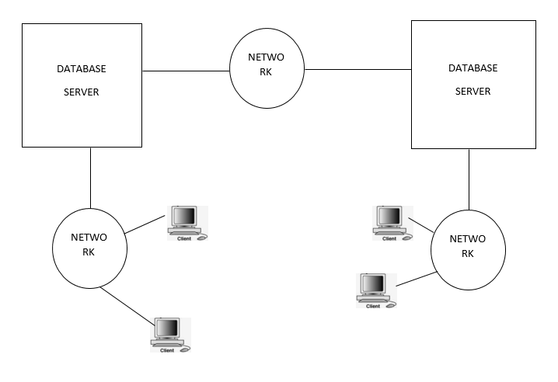

Figure 1: Client-Server Architecture Diag

### **2.2.2 Proposed System Architecture**

The proposed system has a number of key components. Each component has designated function within the system. Below is a list of the components and their functionality explained:

#### **2.2.2.1 User Interface**

It the point where the users interact with the system. It is composed of a web interface which will be accessed through a browser and a user dashboard where users get to interact and access the functionality of the system. There will also be a group administrator’s dashboard where a group leader will be able to schedule event, accept new memberships and post group’s content. And so will be a system admin dashboard.

#### **2.2.2.2 Application Layer**

It represents the layer where application-specific logic resides and is responsible for implementing the core functionalities of the system. In this system some of the components involved in the application layer area:

1. User authentication: Will manage user registration, login, and authentication processes, ensuring secure access to the system's features.
2. Messaging System: Will enable real-time communication between users, allowing them to discuss task details, negotiate terms, and provide updates.
3. Scheduling System: Will allow group administrators to schedule upcoming events for their members
4. Recommendation System: Will provide possible recommendations to users who are not aware of their interests through IQ tests.
5. Membership Systems: Will facilitate students request to join groups and the process of groups accepting ones membership.
6. Rating and Review System: Will allow users to rate and review service providers based on their experiences, contributing to the groups’ trustworthiness and reputation.

#### **2.2.2.3 Data Layer**

The data layer stores and manages the system's data, including user profiles, scheduled events, posted content, group members and other group data, groups profile and many more. It consists of the following:

Relational Database: Will store structured data in tables, ensuring efficient retrieval and management of user and task-related information.

File Storage: Will store multimedia files (e.g., images, documents) associated with tasks and user profiles, allowing for seamless content delivery and management.

The diagram show the visual representation of the architecture used:

Figure 2:Proposed Syst Architecture Diag

**Data Layer**

Web Interface

User Dashboard

Group Admins Dashboard

System Admins Dashboard

User Authentication

Messaging System

Scheduling System

Recommendation System

Membership System

Rate and Review System

Relational Database

File Storage

**Data Layer**

**Application Layer**

**User Interface**

## **2.3 System Development Requirements**

### **2.3.1 Software Requirements**

1. **Integrated Development Environment (IDE):**

Visual Studio Code Will be the most suitable IDE for the design of the System

1. **Database Management System (DBMS):**

MySQL will fit the data storage requirements and preferences.

1. **Programming Languages:**

To build the user interface, HTML, CSS, and JavaScript will be used. For the back-end, PHP will be the most suitable.

### **2.3.2 Hardware Requirements**

1. **Development Workstations:**

High-performance desktop or laptop computers for developers to write, build, and test code.

1. **Storage:**

Storage Area Network (SAN) and Network Attached Storage (NAS) for storing application data, user files, and backups.

Solid State Drives (SSDs) and Hard Disk Drives (HDDs) depending on performance and storage requirements.

1. **Server Infrastructure:**

Web Servers will be expected to handle incoming user requests. The Database Server will be the one hosting the database management system (DBMS).

# **CHAPTER THREE**

# **SYSTEM DEVELOPMENT METHODOLOGY**

## **3.1 Introduction**

This chapter, will explain the system development approach tailored for the Co-Curricular Activity Management System. This approach offers a structured method to craft, deploy, and uphold a seamless software solution that streamlines the systems functionalities. The methodology used was carefully selected to ensure that the system is efficient, effective, and meets user needs.

## **3.2 System Development Model**

The chosen system design methodology for the system is the Agile development model. This approach brings about flexibility, collaboration, and iterative improvement throughout the development process. The key phases of this approach include:

**Initiation**

This involves defining the project goals, scope, and requirements. Identifying key features and prioritize them based on customer needs and business value.

**Planning**

User Stories: Requirements are captured as user stories, each describing a specific functionality from the perspective of an end-user. These stories are written collaboratively by the development team and stakeholders.

Sprint Planning: The project backlog is broken down into smaller tasks, and sprint planning sessions are held to select the tasks for the upcoming sprint. I will estimate the effort required for each task and commits to completing them within the sprint duration.

**Execution**

Sprint Execution: Development work begins with a sprint, typically lasting 1-4 weeks. The team works on the selected tasks, implementing features, and functionality according to the user stories.

**Review and Feedback**

Sprint Review: At the end of each sprint, a review is conducted to demonstrate completed work to stakeholders. Feedback is gathered, and any necessary adjustments are made to the product backlog based on stakeholder input.

**Deployment**

Incremental Deployment: Agile promotes the delivery of working software at the end of each sprint. Incremental updates and improvements are deployed regularly, allowing stakeholders to see tangible progress and provide feedback early in the development process.

The following are advantages of the Agile Development Model:

1. Flexibility and adaptation- Agile allows for flexible and iterative development, allowing us to refine procedures based on feedback and evolving requirements.
2. Focus on Customer Satisfaction- Agile prioritizes customer satisfaction by delivering features and functionality that provide the most value to users. By continuously assessing and reprioritizing the project backlog based on customer feedback and changing market conditions, the team can ensure that the system meets the evolving needs of service seekers and providers.
3. Quality and Transparency- Agile encourages continuous testing, integration, and validation throughout the development process. By breaking down work into smaller, manageable tasks and conducting regular code reviews and testing, the team can identify and address issues early, leading to higher-quality software.

Disadvantages of the approach:

1. Potential Scope Creep- Agile methodologies accommodate changing requirements, but can lead to scope creep if not handled properly. Ongoing feedback and changes may result in project extensions that may affect project timelines and budgets. It is important to set clear boundaries and manage requirements effectively to avoid creeping into the impact of the development process.
2. Lack of Predictability- Agile methodologies prioritize adaptability and responsiveness to change, which can make it challenging to predict project timelines and deliverables. This can be a concern for stakeholders who require a clear timeline or have fixed deadlines. The iterative nature of Agile may lead to uncertainty regarding when specific features or functionalities will be implemented.

## **3.3 Fact Finding Technique**

### **3.3.1 Interviews**

One-on-one interviews was conducted with users which are the students and group admin to gather information about their needs, expectations and pain points. I prepared structured and semi-structured questions to guide the interview process.

**Advantages of using Interviews:**

1. Clarifies ambiguity: Interviews allowed team members to ask questions and explore clarity in real time. This helped eliminate any ambiguity or misunderstanding of the project requirements, creating a clear understanding between the development team and stakeholders
2. Context Insight: Team members gained insight into existing processes, business processes and challenges faced by users. This context was valuable for planning to better meet the specific needs of users.
3. Building Relationships: Conducting interviews enabled participants to build relationships with stakeholders. This contributed to better collaboration throughout the project and built trust between the development team and stakeholders.

**Disadvantages of using Interviews:**

1. Time-consuming: Conducting interviews was a time-consuming process, especially due to dealing with a large number of users. Planning, preparing questionnaires, interviewing, and analyzing data collected was time-consuming, potentially delaying the project timeline
2. Limited perspective: Interviews are subjective and depend on the opinions, experiences and knowledge of the respondents. This led to biases or limited opinions. It may have neglected certain aspects or failed to capture the full range of user needs, resulting in incomplete or inaccurate requirements
3. Miscommunication and misinterpretation: Miscommunication or misinterpretation may have occurred during interviews, leading to misunderstandings or misconceptions. Interviewers and interviewees may have had different interpretations of certain terms or concepts, which may have affected the validity of the data collected.

### **3.3.2 Surveys and Questionnaires**

The project members distributed electronic surveys and questionnaires, both online and physically, to a wide number of students in JKUAT in order to get uniform feedback on their needs, preferences, and viewpoints.

**Advantages**

1. Wide Reach: By sending surveys and questionnaires to a lot of different parties, it was possible to simultaneously collect a variety of viewpoints.
2. Standardized Responses: Standardized questions promoted uniformity in the information gathered, and made it simpler to compare and evaluate results.
3. Anonymity and Confidentiality: Participants remained anonymous, which promoted open and honest feedback. It safeguarded sensitive information, and confidentiality measures were put in place.
4. Time and cost efficiency: Surveys and questionnaires were given electronically, which saved time and money compared to performing one-on-one interviews. Additionally, they were passed on without the need for travel to a geographically spread audience.
5. Quantitative Data Analysis: Surveys produced quantitative data that was analyzed statistically to find trends, patterns, and correlations.

**Disadvantages:**

1. Limited in depth: Questions and surveys provided respondents with limited information to elaborate on their answers or provide context.
2. Response bias: Respondents may have had different meanings or interpreted questions differently, resulting in response bias or inaccuracies in the data collected.
3. Low response: There was a risk of low response rates, which affected the representativeness and validity of the data collected. Some participants did not participate, identifying potential sources of bias.
4. Lack of Flexibility: Surveys have predetermined questions and answers, which limited the ability to pick up on confusion or unexpected topics that may have arisen in open discussion.
5. Failure to clarify ambiguities: Unlike interviews or focus groups, there was no opportunity for immediate clarification or follow-up questions to resolve ambiguities there not fully explained in the answer.

## **3.4 Feasibility Study**

### **3.4.1 Technical Feasibility**

The technical feasibility study assessed whether the required technology infrastructure, hardware and software were available for use or could be developed.

Reasons for Conducting the Study:

1. Assessing Infrastructure Compatibility - Determined if the existing technology infrastructure could support the Co-Curricular Activity Management System’s functionalities. Ensuring compatibility avoids costly infrastructure upgrades or replacements.
2. Scalability- Evaluated if the system could handle increasing user demand and accommodate future growth. This consideration was crucial for ensuring long-term sustainability and avoiding performance bottlenecks.
3. Evaluating Performance- The study gauges whether the proposed solution can meet performance benchmarks, encompassing factors like speed, capacity and reliability without hindering the functionality of the system.

### **3.4.2 Economic Feasibility**

This study evaluates the financial capability of implementing and operating the system, analyzing costs, potential benefits, and revenue generation.

Reasons for Conducting the Study:

1. Cost-Benefit Analysis- A thorough comparison is made between projected costs, including system development, software, hardware, integration, maintenance, and operations, against potential benefits and returns on investment (ROI). This analysis helps ascertain if the benefits outweigh the costs, guiding decision-making.
2. Financial Constraints: The study assesses whether the organization has the financial resources to fund system development, implementation, and ongoing operation. It also explores potential funding sources or investment opportunities to address any financial constraints and ensure the project's viability.

### **3.4.3 Social Feasibility**

The social feasibility of the system refers to its compatibility with social and cultural norms, its potential impact on society, and its ability to address social needs and concerns. In the context of this system, several factors contribute to its social feasibility:

1. Accessibility and Inclusivity- The system aims to be accessible and inclusive to all students in the university, including those with diverse backgrounds, abilities, and needs. It provides a platform for students to connect with groups and other like-minded individuals promoting inclusivity and equal access to services.
2. Social Interaction and Networking-The system facilitates social interaction and networking among users by enabling communication, collaboration, and feedback exchange. This can lead to the formation of social connections and networks within the community, enhancing social cohesion and community resilience.

# **CHAPTER FOUR**

# **SYSTEM ANALYSIS AND DESIGN**

## **4.1 Introduction**

This section will review the data to be collected for the Co-Curricular Activity Management System, including diagrams that illustrate the system's design and the code to be implemented. It encompasses understanding the system requirements, creating system models, designing the system architecture, developing the database schema, designing the user interface, and integrating the various components of the system to ensure a seamless user experience for university students and administrators

## **4.2 Data Entry Analysis**

In data entry analysis, the main goals are to specify the kinds of data that will be gathered, their formats, and the processes through which the data will flow through the system.

### **4.2.1 Use of Tables**

Tables are used in data entry analysis to arrange and display information about data fields, validation rules, form layout and other relevant details. They serve as a structured format for documenting and communicating various aspects of the data entry process. The following tables were used:

Users_table

userid: bigint

username: varchar

email_address:varchar

password: varchar

group_table

groupid: bigint

group_name: varchar

category: varchar

profile: text

Group_members_table

id: int

group_id; bigint

user_id: bigint

join_date: timestamp

username: varchar

Posts_table

post_id:int

group_id: bigint

user_id: bigint

post_content: text

post_image: varchar

post_date:timestamp

event_table

event_id: int

group_id:bigint

event_title: varchar

event_date: date

event_description:text

created_at: timestamp

Figure 3: Tables used in the project

## **4.3 Design**

### **4.3.1 Use Case Diagram**

Figure 4: use case diagram

user

Group admin

### **4.3.2 Flow Chart**

Figure : Flow chart

Account

Register

Log in

User page

Create group

Becomes group admin

Join Group

Perform group admin operations eg psoting, scheduling event etc

Views Group posted content, view existing members, participate in group activity

## **4.4 Code**

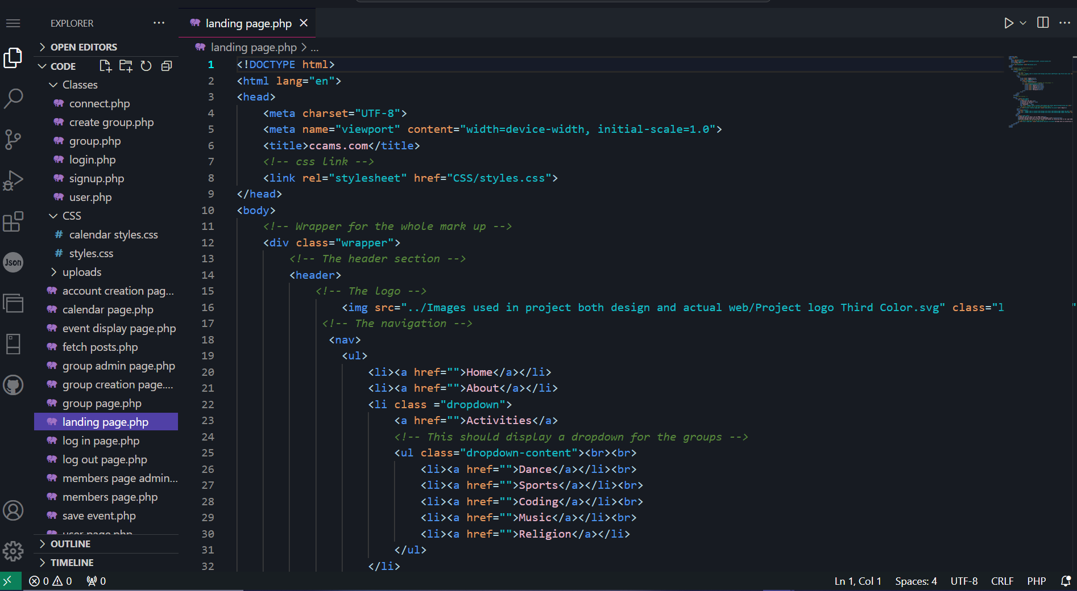

Figure 6: landing page code screenshot

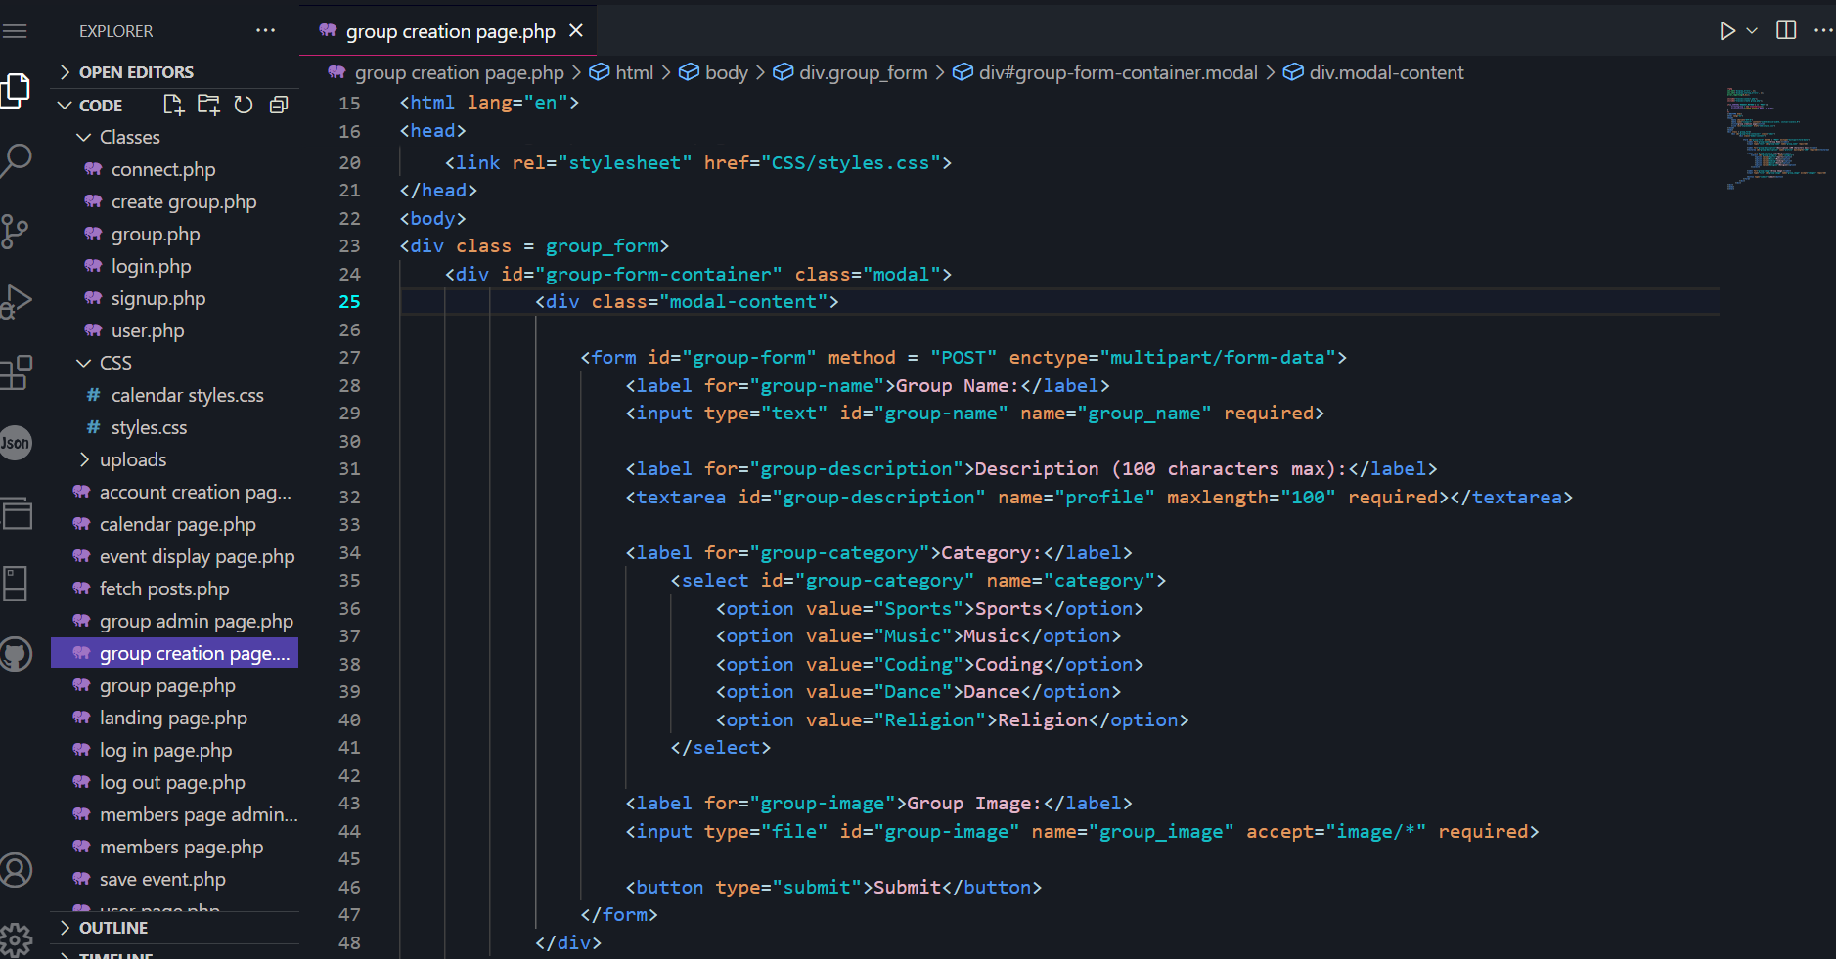

Figure 7: sign up page code

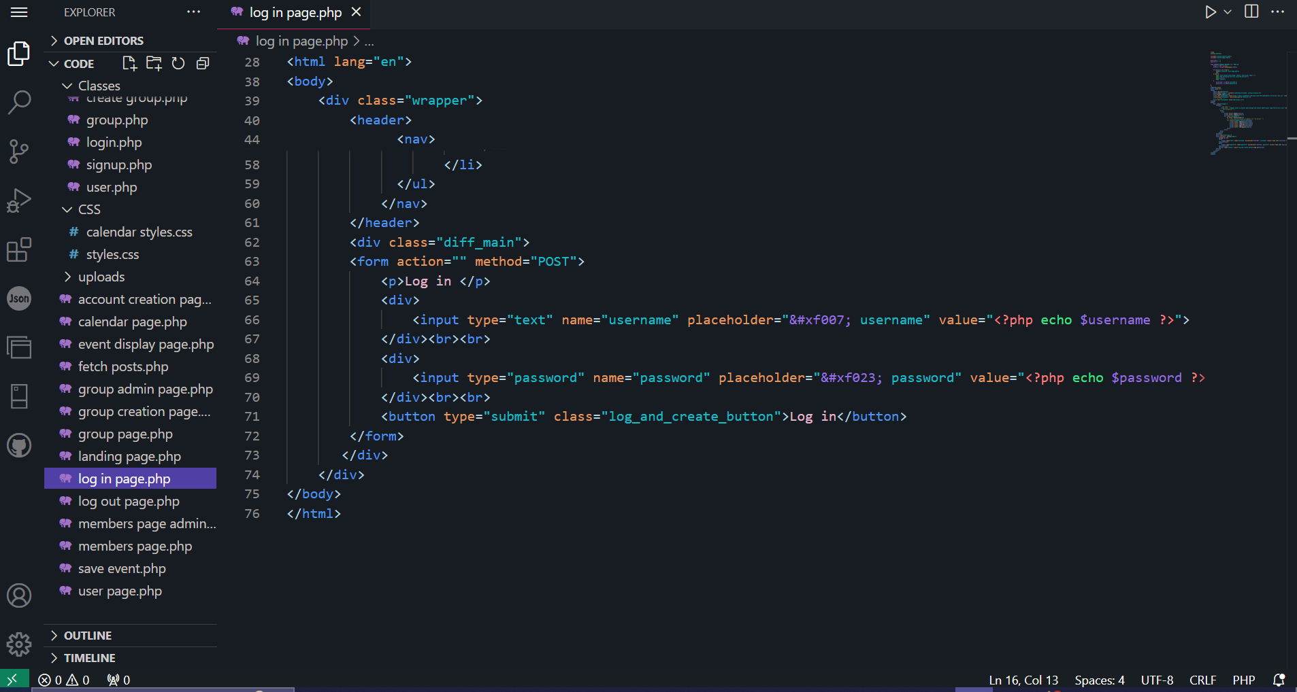

Figure 8: Log in page

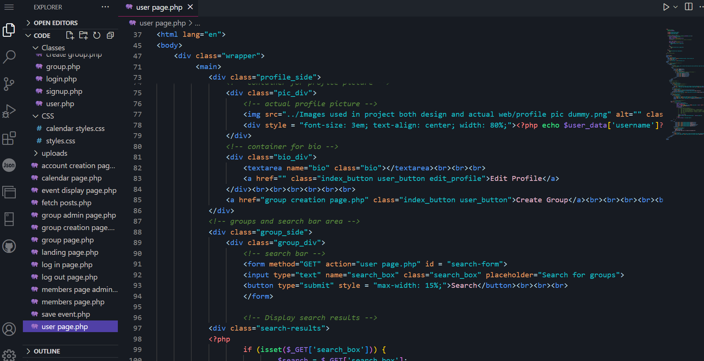

Figure 9: User page code

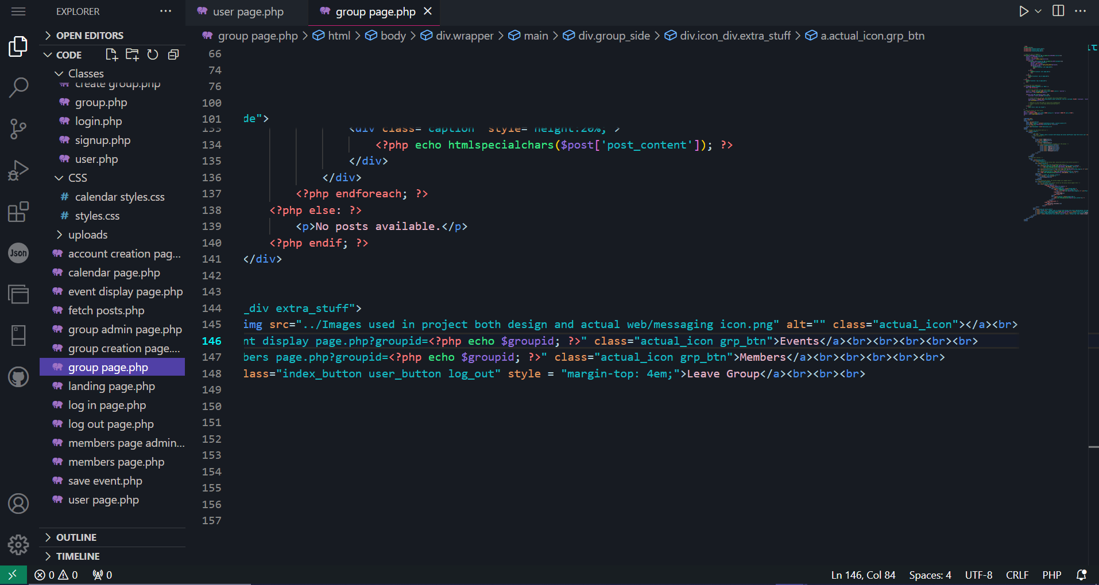

Figure 10: Group page code

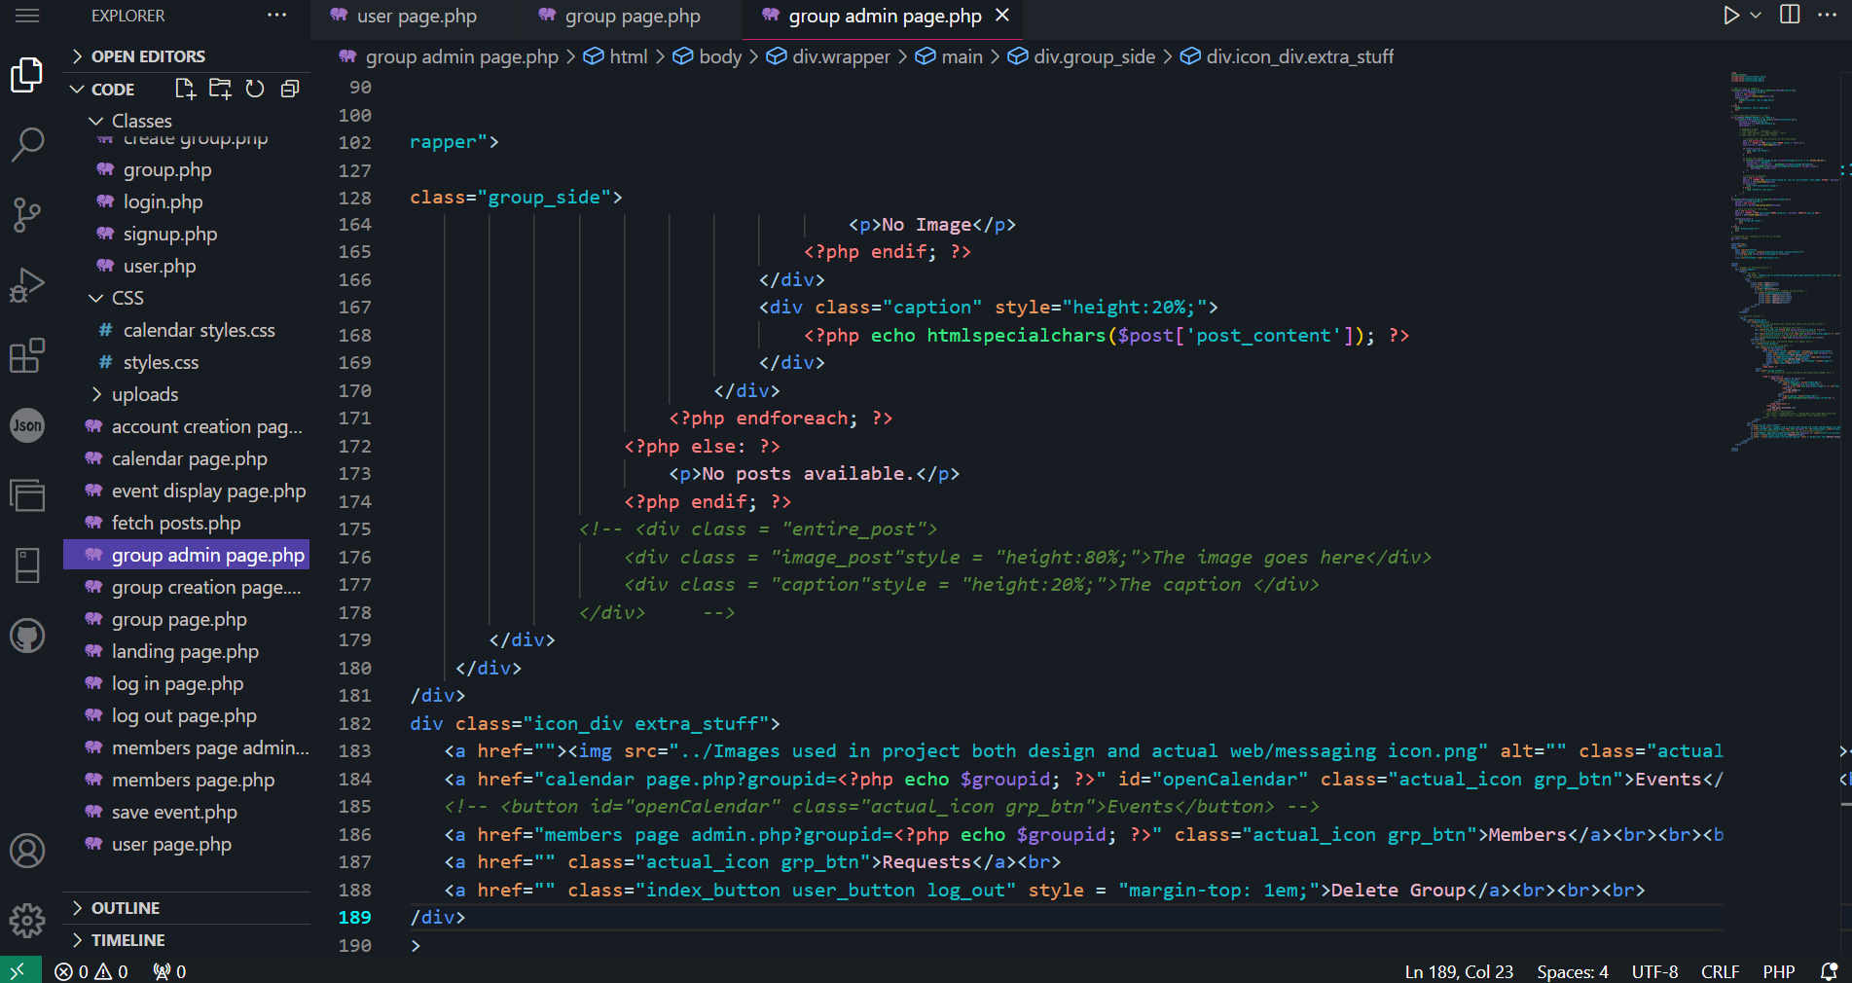

Figure 11: Group admin page code

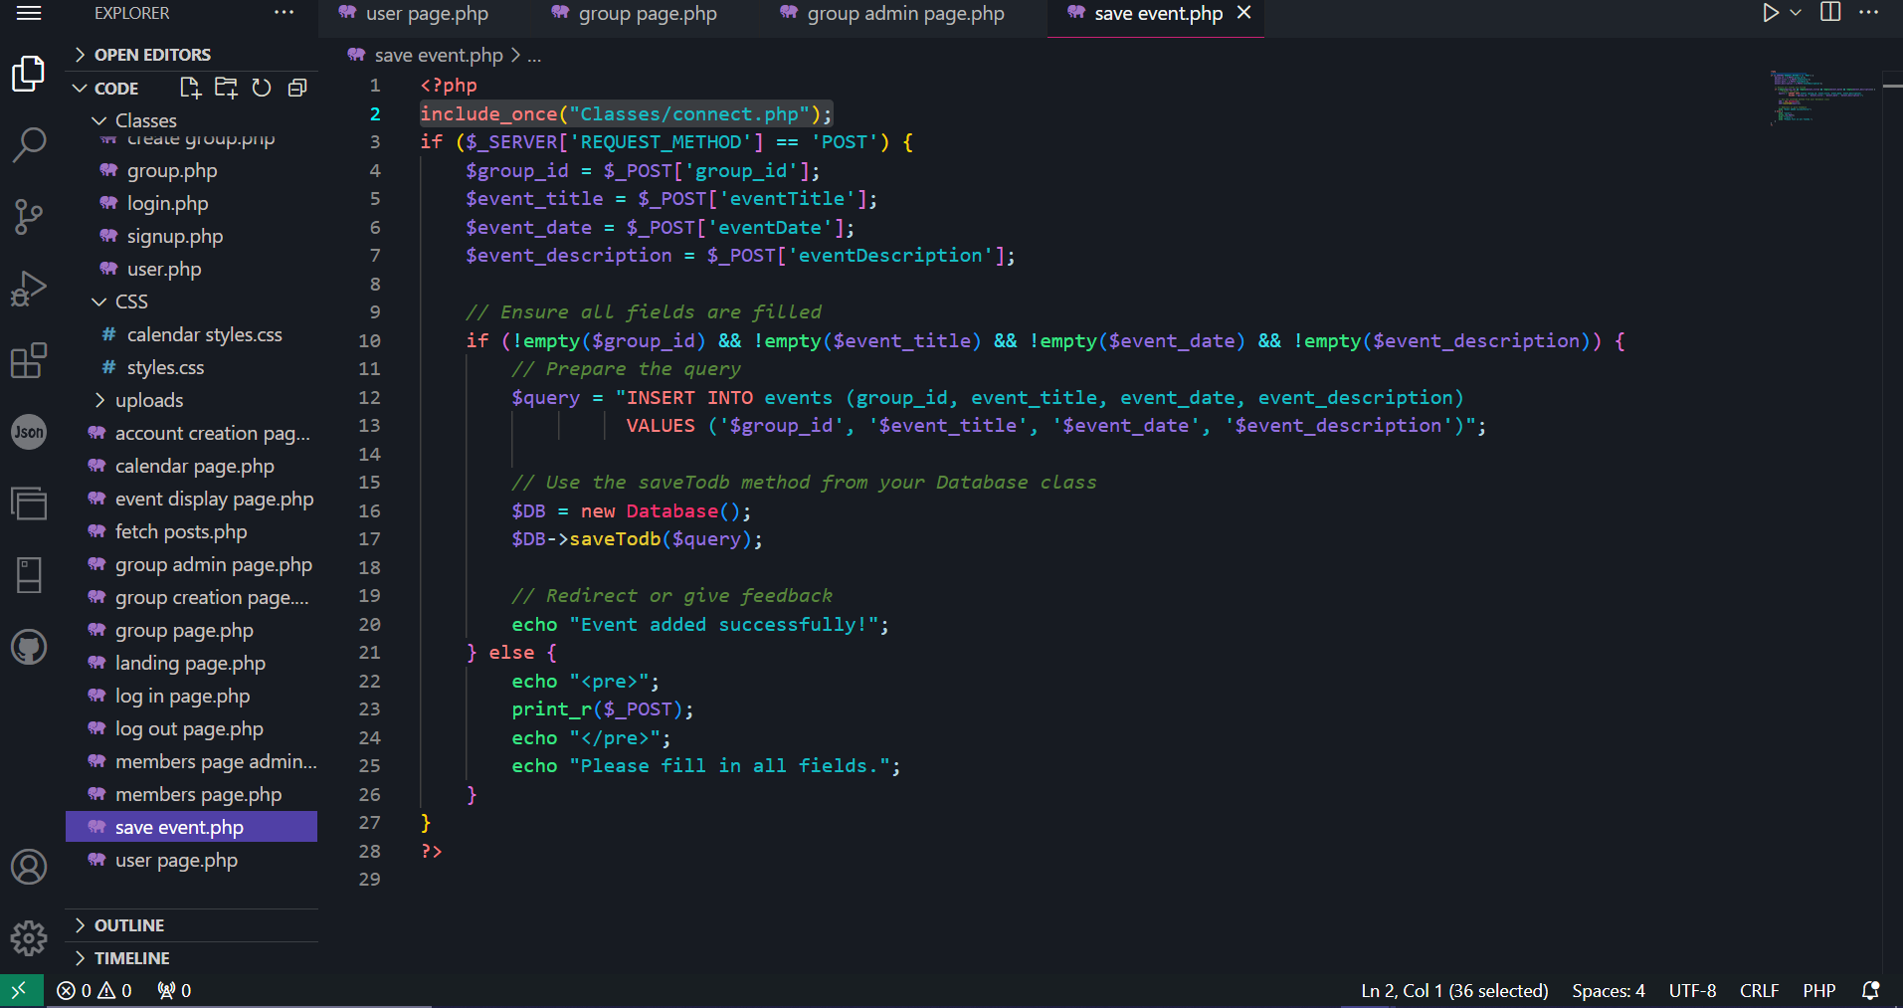

Figure 12: save event page

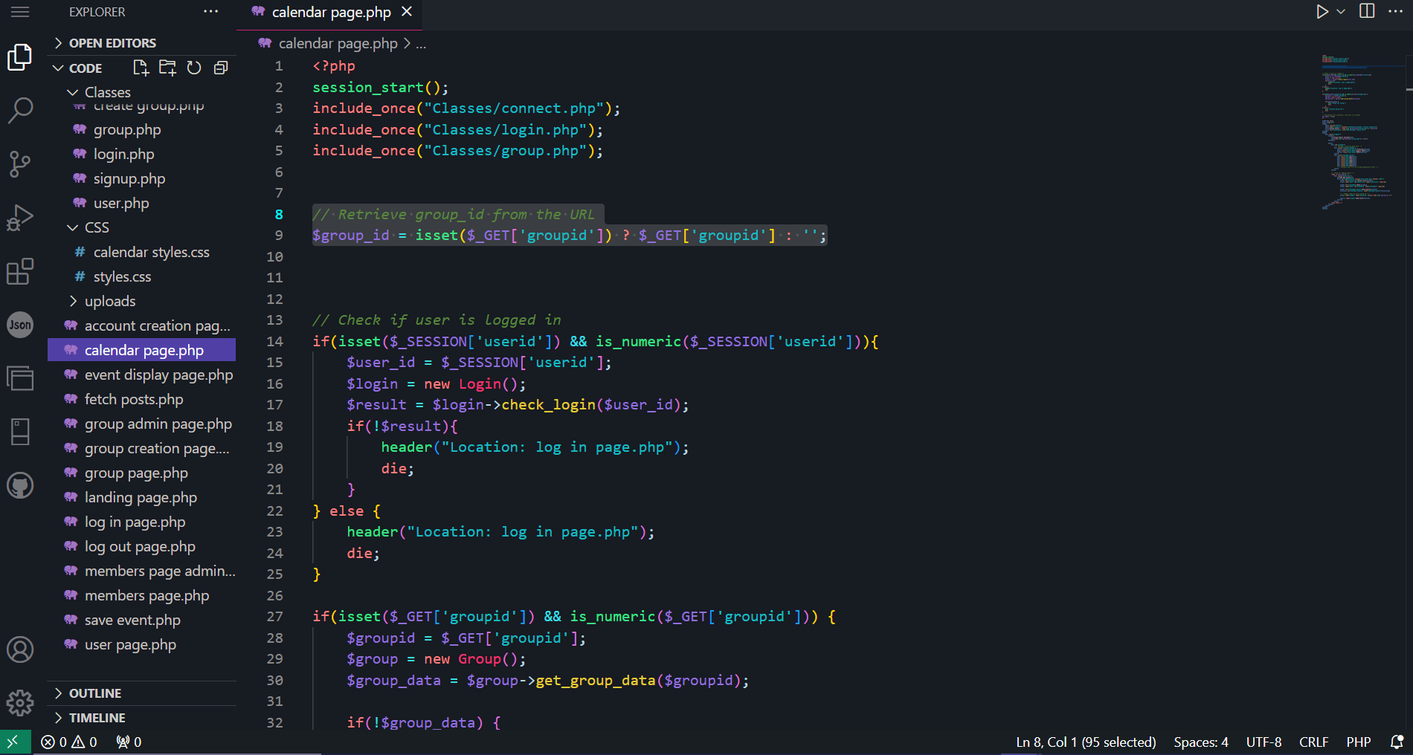

Figure 13: Calendar page code

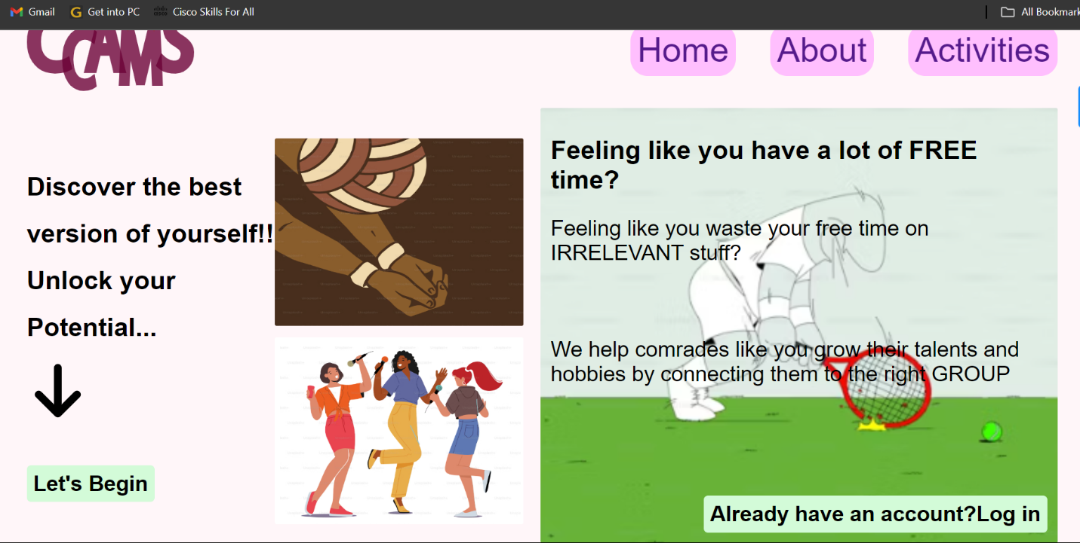

Figure 14: landing page

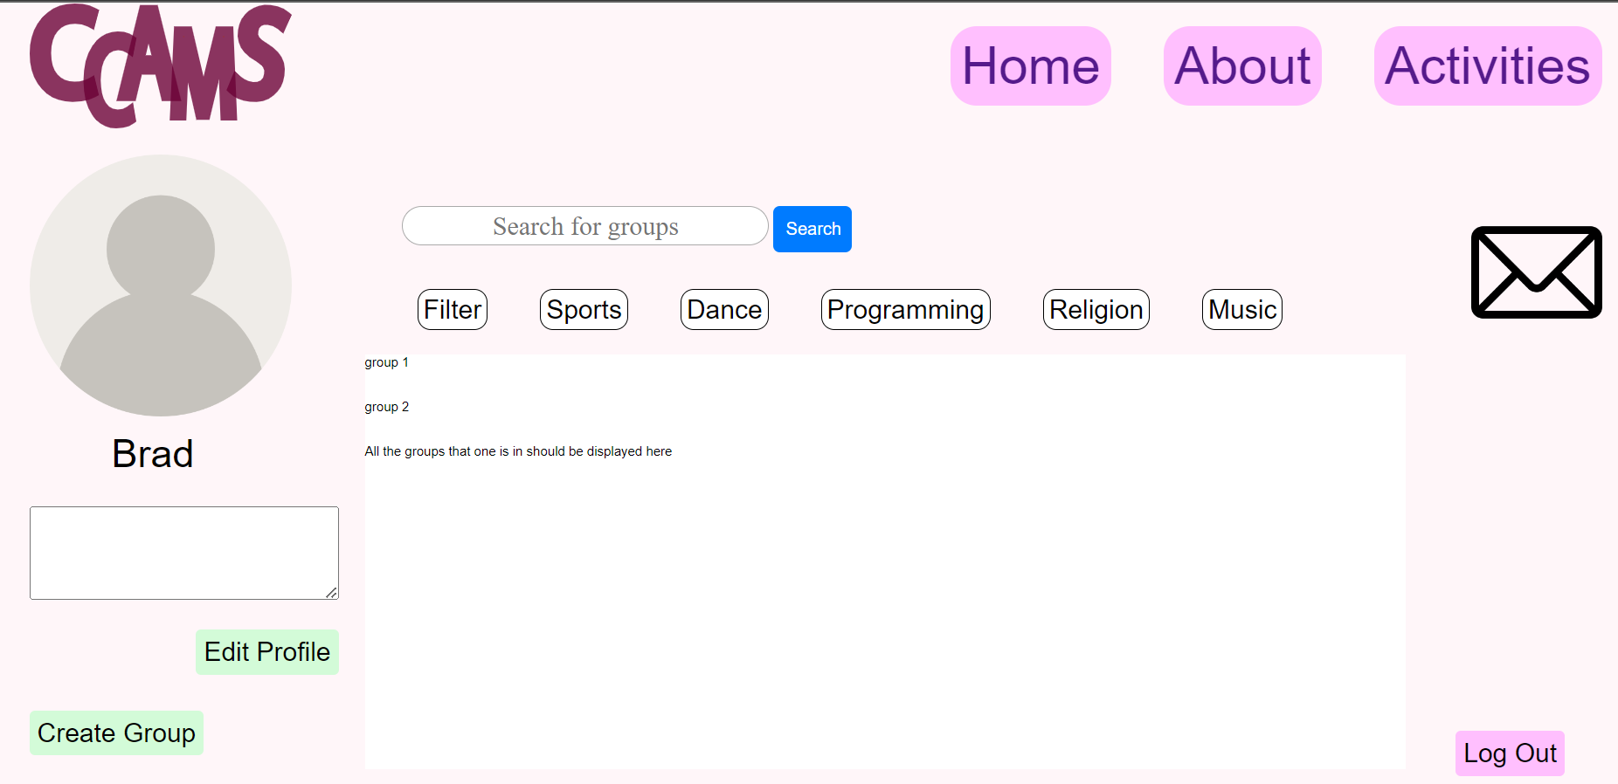

Figure 15: User page

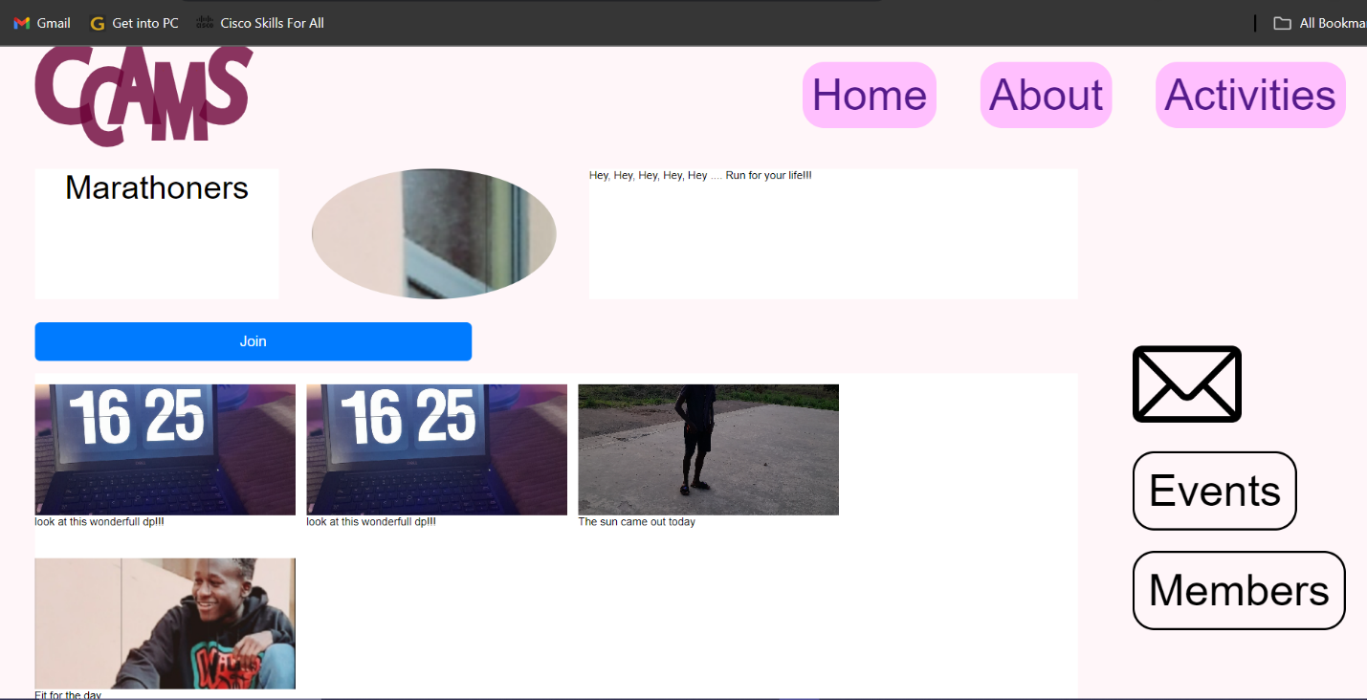

Figure 16: Group page

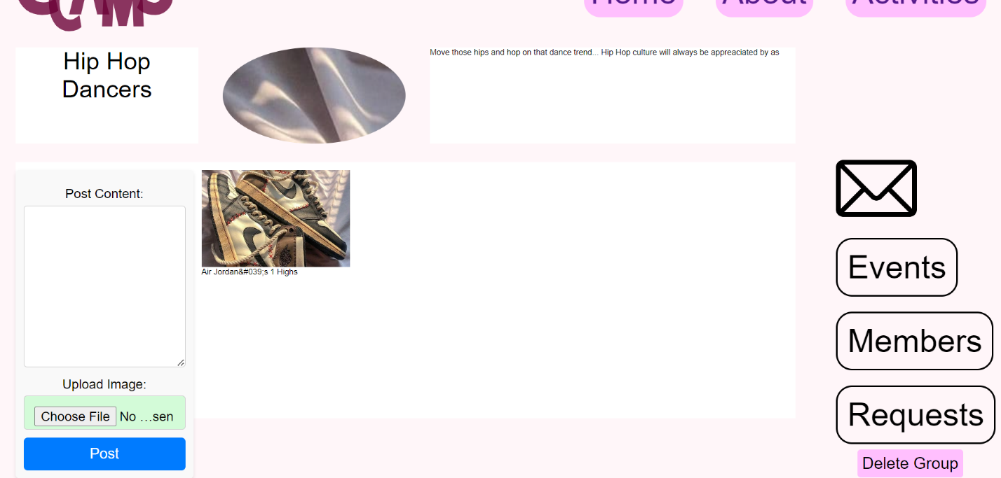

Figure 17: Group admin page

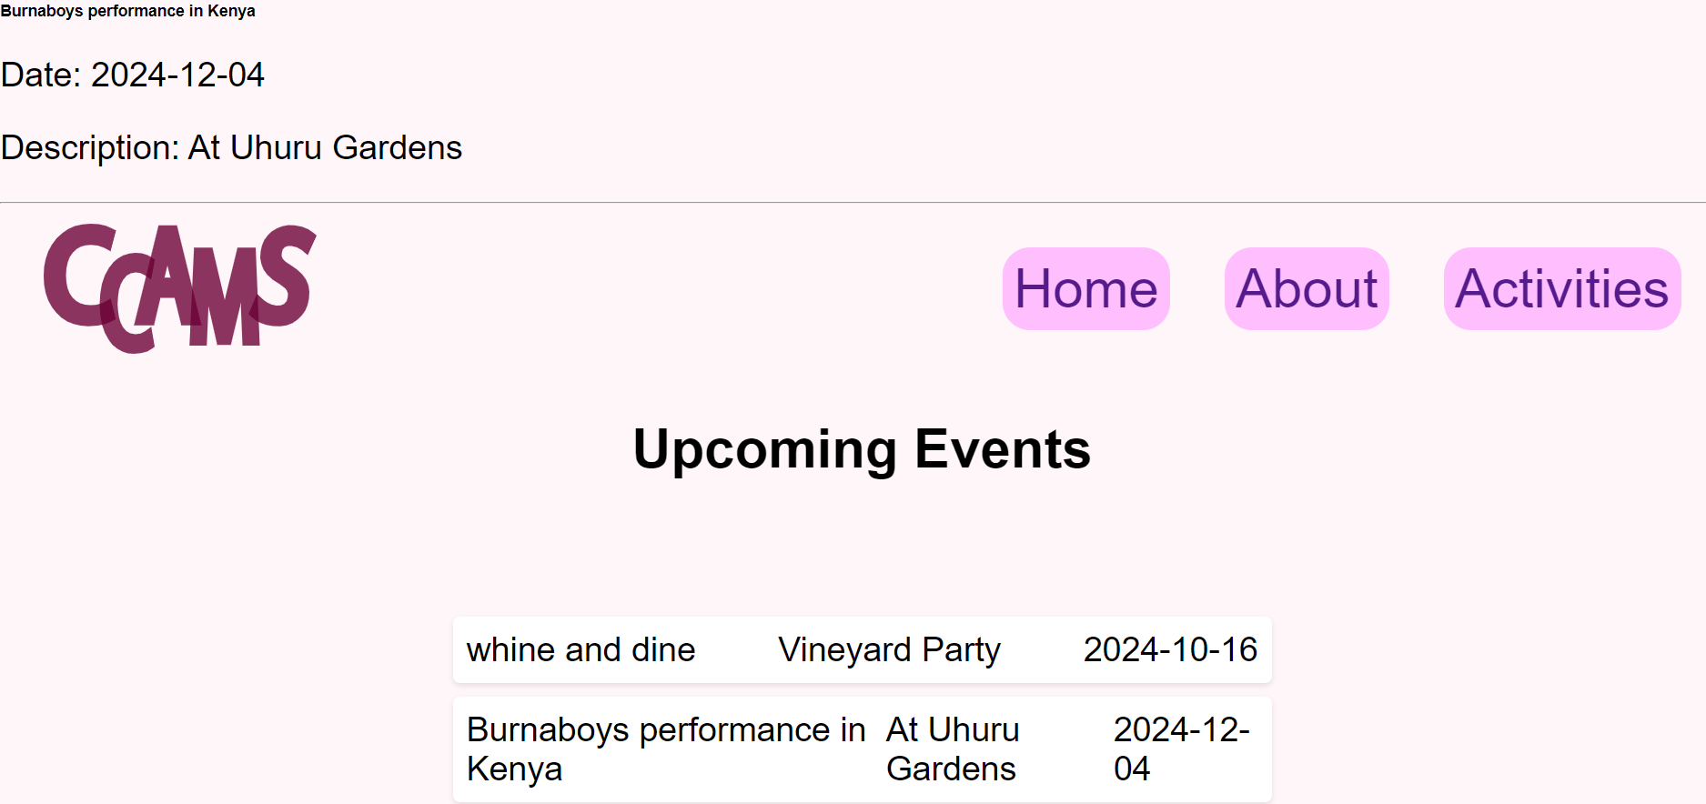

Figure 18: Event display page

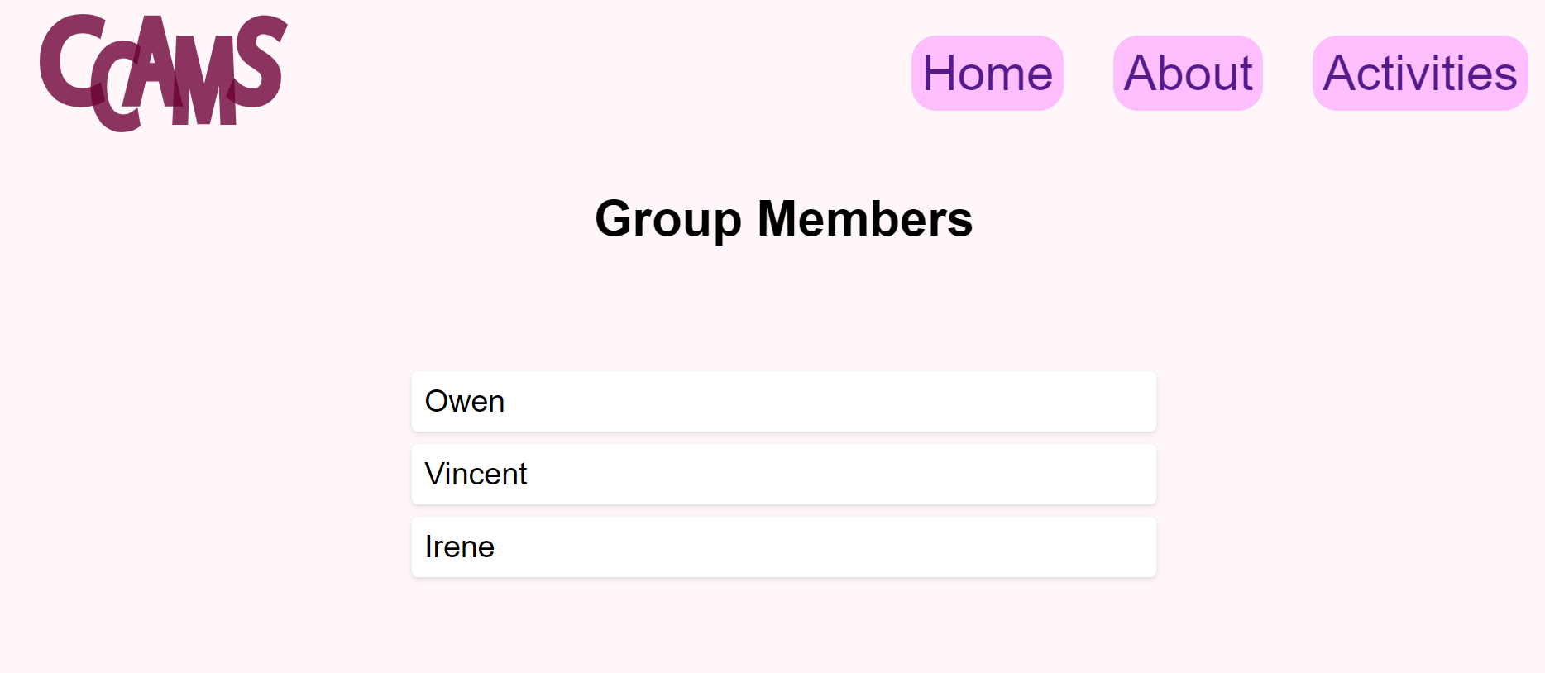

Figure 19: Member page

## **4.5 Conclusion**

In conclusion, the analysis and design of the Co-Curricular Activity Management System involved a systematic approach to understanding, modeling, and implementing the various aspects of the platform. By utilizing diagrammatic tools, the design process was organized, allowing for a comprehensive exploration of user requirements, system components, and process flows. This phase ensured that the needs of all stakeholders, including students, group administrators, and university staff, were met, and that the system's functionalities were clearly defined and seamlessly integrated to enhance student engagement and participation in co-curricular activities.

# **CHAPTER FIVE**

# **SYSTEM IMPLEMENTATION AND TESTING**

## **5.1 Introduction**

The implementation and testing phases were critical in bringing the Co-Curricular Activity Management System (CCAMS) to life. This chapter outlines the transition from the system's design and development to its practical application and operation. The system was deployed as a fully functional platform aimed at enhancing student engagement in co-curricular activities through streamlined group management, event scheduling, content sharing, and communication. Rigorous testing was conducted to ensure that the system performed reliably and securely, meeting the needs of university students and administrators. This chapter also details the techniques used to implement the system, including user training, the development of user manuals, and other essential processes.

## **5.2 Implementation Techniques**

### **5.2.1 Training**

Training was a fundamental component of the system's implementation strategy, ensuring that all users could effectively utilize the platform's features. The training process was structured to accommodate students, group administrators, and university staff, with sessions provided in the form of hands-on tutorials. Key areas covered included creating and managing groups, scheduling events, sharing content, and using the messaging system. By facilitating an interactive learning environment, training sessions helped users gain confidence in navigating the system, thereby reducing the likelihood of errors and ensuring smooth adoption.

### **5.2.2 User Manuals**

User manuals were developed as comprehensive guides to support users in exploring and utilizing the system's capabilities. These manuals were tailored to cater to different user roles, such as students, group administrators, and university staff. Each manual included detailed instructions on how to perform essential tasks, supported by screenshots, diagrams, and troubleshooting tips. The aim was to make the manuals intuitive and accessible, enabling users of varying technical expertise to independently navigate the platform. The manuals were made available in both digital and print formats, ensuring easy access for all users.

### **5.2.3 System Configuration and Customization**

System configuration and customization played a vital role in the successful deployment of the Co-Curricular Activity Management System. This technique involved setting up the system's parameters to align with the specific requirements of the university. Customization options included defining user roles, configuring group management settings, and tailoring the IQ test or interest assessment tool to reflect the diverse range of student activities available. This process ensured that the system was adaptable and responsive to the unique needs of the university community, thereby maximizing its effectiveness.

### **5.2.4 Data Migration**

Data migration was another crucial implementation technique, involving the transfer of existing co-curricular activity records, group information, and user data from legacy systems to the new platform. This process was meticulously planned and executed to ensure the integrity and accuracy of the data. Migration steps included data cleansing, mapping, and validation to prevent errors and ensure that all information was correctly integrated into the new system. By maintaining a seamless transition of data, the system was able to provide continuity in service and a familiar environment for users.

## **5.3 Testing**

### **5.3.1 Unit Testing**

Unit testing was conducted on individual components or modules of the Co-Curricular Activity Management System. Each feature, such as group creation, event scheduling, content sharing, and messaging, was tested in isolation to ensure proper functionality. By addressing issues at this granular level, unit testing ensured that each part of the system operated as expected, providing a solid foundation for further testing phases.

### **5.3.2 Integration Testing**

Following successful unit testing, integration testing was performed to verify that different modules of the system worked together seamlessly. This testing ensured that data flowed correctly between components, such as when a student joined a group, the membership was updated. Integration testing confirmed that the interconnected features of the system worked harmoniously to deliver the intended user experience.

### **5.3.3 System Testing**

System testing involved a comprehensive evaluation of the Co-Curricular Activity Management System as a whole. This phase checked the system’s overall functionality, performance, and adherence to the specified requirements. Real-world usage scenarios, such as group management, event scheduling, and content sharing, were simulated to ensure the system operated correctly under various conditions. The testing verified that users could seamlessly join groups, participate in events, and communicate without encountering errors or performance issues.

### **5.3.4 Regression Testing**

Regression testing was conducted whenever updates or changes were made to the system to ensure that these modifications did not introduce new bugs or disrupt existing functionalities. For instance, when new features were added, regression testing confirmed that these enhancements did not interfere with core functions such as event scheduling. This testing helped maintain the system's stability and reliability throughout its development lifecycle.

### **5.3.5 User Acceptance Testing (UAT)**

User Acceptance Testing (UAT) involved real users—university students and group administrators—interacting with the system to ensure it met their needs and expectations. During UAT, users tested various features such as joining groups, scheduling events, and sharing content, providing valuable feedback on the system’s usability and functionality. This feedback was used to identify and address any usability issues, ensuring that the system was ready for deployment.

### **5.3.6 Performance Testing**

Performance testing assessed the system's responsiveness, stability, and scalability under different usage conditions. This phase tested the system's ability to handle multiple users accessing and using the platform simultaneously. For example, the system was evaluated to ensure that hundreds of students could browse groups, request membership, and interact with event schedules concurrently without experiencing significant delays or crashes. Performance testing ensured that the system remained efficient and responsive under various load conditions.

## **5.4 Conclusion**

### **5.4.1 Challenges**

1. Resistance to Change: Students and staff were accustomed to existing methods of managing co-curricular activities. Encouraging them to transition to a new system was met with resistance.
2. **Scalability:** As the number of users and activities grows, the system needs to scale effectively. Ensuring that the platform can handle increased loads without performance degradation can be challenging, particularly during peak times, like the beginning of the academic year or during major events
3. Data Security: Handling sensitive student data, including personal profiles and communication records, necessitates robust security measures. Protecting this data from breaches, unauthorized access, or other cyber threats is a significant challenge.

### **5.4.2 Recommendations**

1. Engage with Diverse Student Groups

Engage with a wide range of student groups and organizations to gather comprehensive requirements. Conduct surveys, focus groups, and interviews with different student demographics to ensure that the system caters to the diverse needs and interests of all users. Regularly review and refine the system's features based on ongoing feedback to maintain relevance and usability.

1. Ensure Robust Security Measures

Implement strong security protocols, including end-to-end encryption, multi-factor authentication, and regular security audits, to safeguard sensitive user data. Ensure compliance with relevant data protection regulations such as GDPR or local privacy laws. Conduct frequent vulnerability assessments and security drills to proactively address potential threats and protect user privacy.

1. Collaborate with University IT and Stakeholders

Work closely with the university’s IT department and key stakeholders to ensure seamless integration with existing systems, such as student information systems, email platforms, and campus event calendars. Conduct thorough compatibility testing and establish clear communication channels to promptly address any technical issues that arise during and after implementation.

1. Optimize System Performance for Scalability

Conduct extensive performance testing to identify potential bottlenecks and optimize the system’s architecture for scalability. Implement strategies like load balancing, efficient database management, and cloud-based solutions to ensure the system can handle increasing user traffic and data without compromising performance, especially during peak periods like enrollment or major campus events.

1. Involve Students in UX/UI Design

Actively involve students in the design process to create an intuitive and user-friendly interface. Follow best practices in UX/UI design and iterate based on user feedback to ensure the system is accessible and enjoyable to use for students with varying levels of technical expertise. Consider usability testing with a diverse group of users to refine the interface continually.

1. Prioritize Core Features and Flexibility

Focus on developing the most critical features first, such as group management, event scheduling, and communication tools. Consider leveraging open-source technologies and modular design to allow for future enhancements and customizations. Seek additional funding or partnerships to support the development of advanced features like the IQ test or interest assessment tool.

1. Implement a Comprehensive Testing Strategy

Develop a structured testing plan that includes unit, integration, system, and user acceptance testing at each stage of development. Engage students in beta testing to identify and resolve issues early, ensuring the system meets user needs and expectations. Regularly update the testing framework to incorporate new features and enhancements.

1. Adopt a Clear Change Management Strategy

Implement a clear change management strategy that includes ongoing communication about the benefits of the new system. Provide continuous support and resources, such as help desks and online forums, to assist users during the transition. Address any resistance by actively listening to user concerns and incorporating their feedback into the system’s ongoing development.

1. Establish a Responsive Support System

Create a dedicated support team to handle user inquiries, technical issues, and system maintenance. Schedule regular updates and maintenance checks to keep the system running smoothly and securely. Continuously gather user feedback through surveys and user forums to identify areas for improvement and ensure the system evolves to meet changing student needs.

## **5.4.3 Budget and Work plan**

# **WORK SCHEDULE**

**Week 1: Project Initiation and Planning**

Define project objectives and scope

Conduct stakeholder meetings to gather initial requirements

Develop a high-level project plan and timeline

**Week 2-3: Requirements Gathering and Analysis**

Conduct detailed requirements analysis with stakeholders

Define system functionalities and features

Create user stories and use cases

**Week 4-5: System Design and Architecture**

Design system architecture and components

Develop database schema and initial data models

**Week 6-9: Development and Implementation**

Implement core system functionalities

Develop user interface and navigation

**Week 10-12: Testing, Deployment, and Evaluation**

Perform system testing, including unit and integration testing

Conduct user acceptance testing with stakeholders

Deploy the telemedicine platform to production environment

Collect feedback and evaluate system performance

|  |  |  |
| --- | --- | --- |
| PHASE | ACTIVITIES | TIMELINE |
| Planning and Research | * Define requirements * Planning * Requirement gathering | 3 Weeks |
| Design | * User interface design * Database design | 2 Weeks |
| Development | * Frontend development * Backend development | 3 Weeks |
| Testing and quality assurance | * Unit testing * Performance integration testing | 4 Weeks |

# **BUDGET**

This section provides a detailed budget for the proposed project. The budget is designed with consideration of the essential resources required to successfully develop, implement, and evaluate the community health toolkit. As a student-led project, this budget is optimized for cost-effectiveness, leveraging available free and discounted resources where possible, while ensuring the quality and reliability of the project's outcomes.

**Software Costs**

**Development Tools**: Access to integrated development environments (IDEs) and text editors is essential for efficient coding and debugging. While many tools offer free versions, a budget allocation for professional versions can enhance productivity with additional features. **Estimated Cost: Ksh 5,000 - 10,000.**

**Cloud Services**: The project will utilize cloud services for hosting the application, database management, and data backups. Free tiers will be utilized where possible, with budgeted funds allocated for additional resources as needed. **Estimated Cost: Ksh 10,000.**

**Hardware Costs**

**Personal Computer Upgrades or Peripherals**: Assuming the availability of a personal computer, minor upgrades or peripherals may be required to optimize performance for development tasks. **Estimated Cost: Ksh 0 - 5,000.**

**Internet Access**: Reliable internet access is crucial for research, development, and cloud services interaction. This budget line covers the estimated cost of internet services over the project duration. **Estimated Cost: Ksh 3,000 -4000.**

**Miscellaneous Supplies**

**Printing and Stationery**: For the printing of documents, questionnaires, and other materials essential to the research process. **Estimated Cost: Ksh 2,000 - 5,000.**

**Total Estimated Budget**

The total estimated budget for the project ranges from **Ksh 15,000 to Ksh 23,000**. This budget is carefully tailored to cover the project's essential needs while maintaining cost-effectiveness, ensuring that the project is feasible and sustainable as a student-led initiative.

# **5.4.4 References**

Sisson, S. B., McClain, J. J., & Tudor-Locke, C. (2008). Campus walkability, pedometer-determined steps, and moderate-to-vigorous physical activity: a comparison of 2 university campuses. *Journal of American College Health*, *56*(5), 585-592.

Bergen-Cico, D., & Viscomi, J. (2012). Exploring the association between campus co-curricular involvement and academic achievement. *Journal of college student retention: Research, theory & practice*, *14*(3), 329-343.

Crowe, K. M. (2010). Student affairs connection: Promoting the library through co-curricular activities. *Collaborative librarianship*, *2*(3), 5.

Sami, A., & Irfan, A. (2020). Academic Achievement of college students based on Co-curricular Activities. *Journal of Management Info*, *7*(1), 16-23.

Leung, C. H., Ng, C. W. R., & Chan, P. O. E. (2011). Can Co-Curricular Activities Enhance the Learning Effectiveness of Students?: An Application to the Sub-Degree Students in Hong Kong. *International Journal of Teaching and Learning in Higher Education*, *23*(3), 329-341.

Massi, L., Lancey, P., Nair, U., Straney, R., Georgiopoulos, M., & Young, C. (2012, October). Engineering and computer science community college transfers and native freshmen students: Relationships among participation in extra-curricular and co-curricular activities, connecting to the university campus, and academic success. In *2012 Frontiers in education conference proceedings* (pp. 1-6). IEEE.

Dunbar, R. I., Arnaboldi, V., Conti, M., & Passarella, A. (2015). The structure of online social networks mirrors those in the offline world. *Social networks*, *43*, 39-47.

Barreda, A. A., Bilgihan, A., Nusair, K., & Okumus, F. (2015). Generating brand awareness in online social networks. *Computers in human behavior*, *50*, 600-609.

Hamid, S., Waycott, J., Kurnia, S., & Chang, S. (2015). Understanding students' perceptions of the benefits of online social networking use for teaching and learning. *The Internet and higher education*, *26*, 1-9.

Perilla, F. S., & Malicdem, A. R. (2019). Design Architecture of a Student Co-curricular Activity Management Platform. *International Journal of Recent Technology and Engineering (IJRTE)*.

Rahman, S. R., Islam, M. A., Akash, P. P., Parvin, M., Moon, N. N., & Nur, F. N. (2021). Effects of co-curricular activities on student's academic performance by machine learning. *Current Research in Behavioral Sciences*, *2*, 100057.